**Lab #7**

**CECS 378 – Spring 2021 – Cappel & Uuh**

**Due:** Wednesday, April 28th by 11:59 PM

**Lab #7 is focused on learning the essentials of cloud computing and a little bit about security in the cloud. We will be focusing on one of the big three cloud provider solutions – Amazon Web Services (AWS).**

**This lab will be leveraging the AWS Cloud Practitioner Essentials course which is a fundamental-level course intended for individuals who seek an overall understanding of the AWS Cloud, independent of specific technical roles. It provides a detailed overview of cloud concepts, AWS services, security, architecture, pricing, and support. This course also helps you prepare for the AWS Certified Cloud Practitioner exam if you would like to pursue that credential.**

**The course will be done remotely using the AWS web site residing on the internet. There are 11 modules and a final course assessment available in this course. Each of the first 10 modules will be worth 10 points each. You can receive 2 extra credit lab points for doing module 11 and 3 extra credit lab points for completing the final course assessment.**

**Course Objectives**

In this course, you will learn how to:

* Summarize the working definition of AWS.
* Differentiate between on-premises, hybrid-cloud, and all-in cloud.
* Describe the basic global infrastructure of the AWS Cloud.
* Explain the six benefits of the AWS Cloud.
* Provide examples of core AWS services, including compute, network, databases, & storage.
* Identify an appropriate solution using AWS Cloud services with various use cases.
* Describe the AWS Well-Architected Framework.
* Explain the shared responsibility model.
* Describe the core security services within the AWS Cloud.
* Describe the basics of AWS Cloud migration.
* Articulate the financial benefits of the AWS Cloud for an organization’s cost management.
* Define the core billing, account management, and pricing models.
* Explain how to use pricing tools to make cost-effective choices for AWS services.

**Task 1 – Create an account on the Amazon website.**

Perform the following steps from your standard laptop:

1. Access the course on the Amazon website by going to the following URL:

[**https://www.aws.training/Details/eLearning?id=60697**](https://www.aws.training/Details/eLearning?id=60697)

1. On the main menu at the top of the page, select the sign in link.
2. At the next web page, select the sign in link under the amazon section (not the partner network).
3. At the next web page, sign in using an existing Amazon account or select the Create your Amazon Account link if you don’t have an Amazon account.

**Note**: At this point, you should be on your way. Please follow all the instructions in the course.

**Task 2 – Perform Modules 1 thru 10 in the AWS Cloud Practitioner Essentials Course.**

**Note**: Grading for the *required* modules will be based on the following point distribution.

1. **Module 1**

– Introduction to AWS (10 points)

1. **Module 2**

– Compute in the Cloud (10 points)

1. **Module 3**

– Global Infrastructure and Reliability (10 points)

1. **Module 4**

– Networking (10 points)

1. **Module 5**

– Storage and Databases (10 points)

1. **Module 6**

– Security (10 points)

1. **Module 7**

– Monitoring and Analytics (10 points)

1. **Module 8**

– Pricing and Support (10 points)

1. **Module 9**

– Migration and Innovation (10 points)

1. **Module 10**

– The Cloud Journey (10 points)

**Note**: This concludes all the modules *required* for CECS 378 Lab 7.

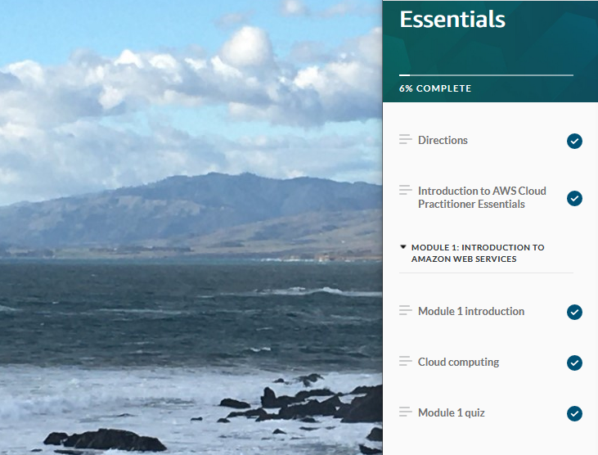

Submit screen shots of all the modules you have completed along with something unique in the background on your particular laptop using the snipping tool (like the screen shot shown above).

Include any modules listed below you may have completed for extra credit.

Post a file containing your screen shots in dropbox on BeachBoard to validate you performed CECS 378 Lab 7.

The document containing your screen shots is the only required document to be submitted for CECS 378 Lab 7.

Make sure your screen shots show you have completed all required portions of each module.

**Task 3 – **EXTRA CREDIT** Perform Module 11 and the Final Assessment.**

**Note**: These are not *required* but are available for extra credit lab points.

1. **Module 11 (2 extra credit points for labs)**

– AWS Certified Cloud Practitioner Basics

1. **Final Assessment (3 extra credit points for labs)**